CLOUD COMPUTING LAB2

NAME- HAMSINI RAMESH

SRN- PES2UG21CS183

SECTION- D

Screenshot 1a: Public Route Table

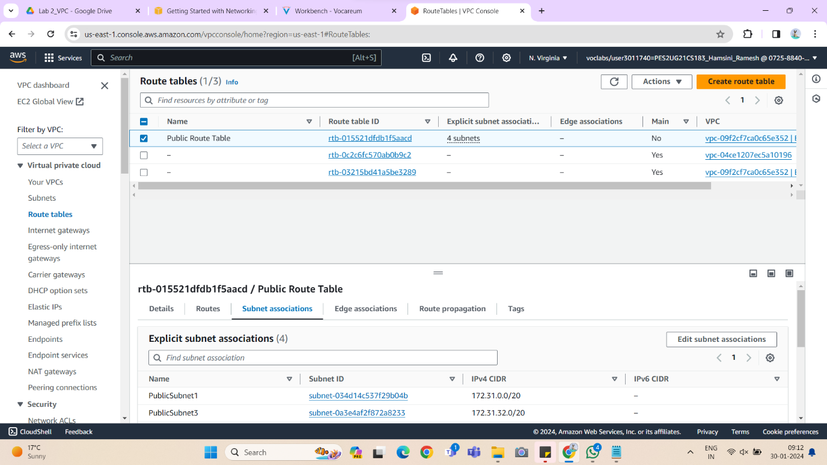

Screenshot 1b: Editing Inbound Rules for Web-Server-SG

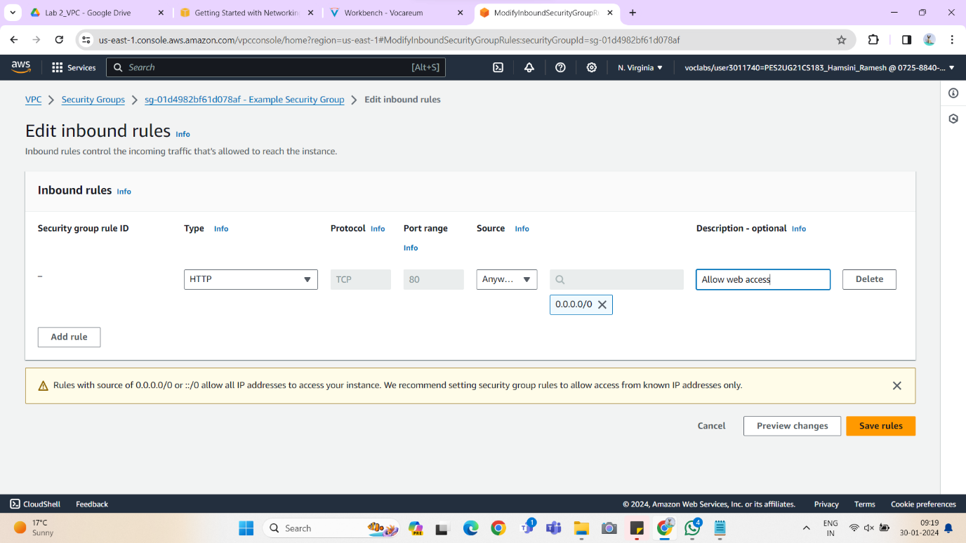

Screenshot 1c: Website hosted by the EC2 instance

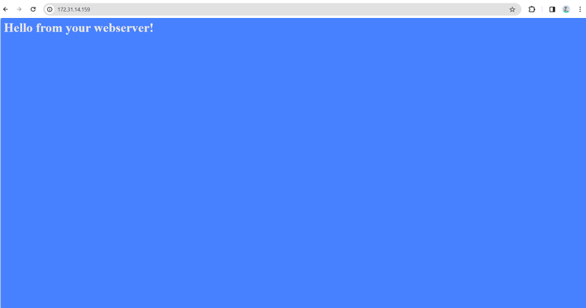

Screenshot 1d: Creating VPC along with the preview

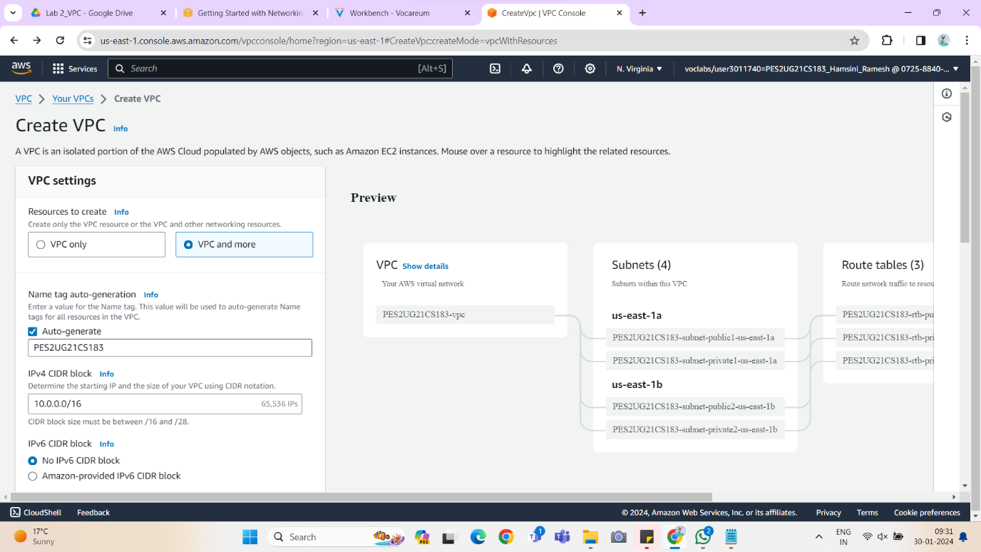

Screenshot 1e: Created VPC

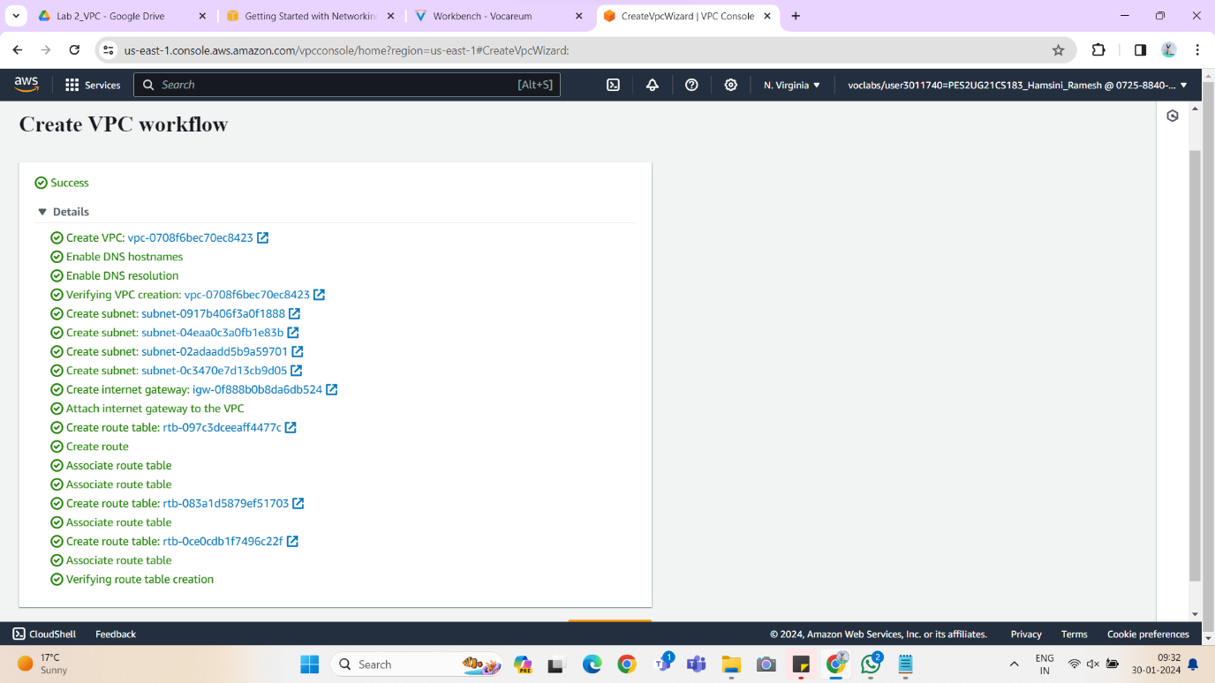

Screenshot 1f: Created Security Group

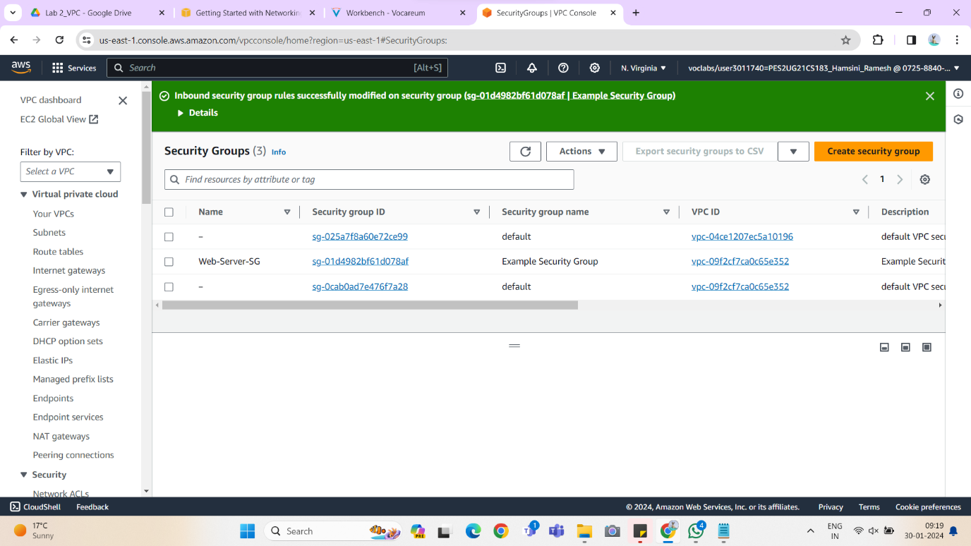

Screenshot 1g: Summary of the configured EC2 instance for custom VPC

